Employee Overview
Employee full name
Job title
Service Line/Department
Manager
Manager 2 (in case of double reporting Line)
Studio
Location
Review period

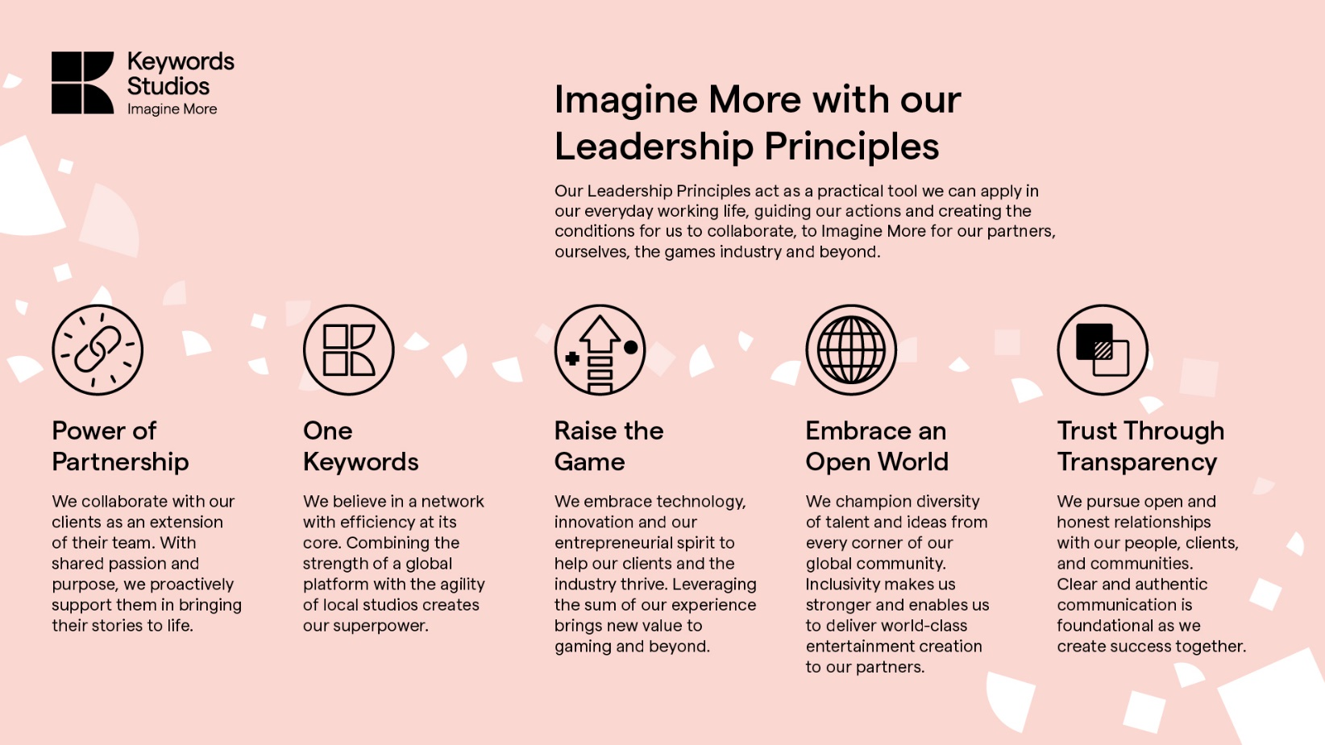

SELF APPRAISAL | MANAGER APPRAISAL

Overall self-evaluation of the year | Choose an item. | Overall evaluation of the year | Choose an item.

Please outline your key achievements during the year. | What were the key achievements that you recognized and valued most during the year?
For each comment below we encourage you to link your achievements to our Leadership Principles where you can | For each comment below we encourage you to refer to our Leadership Principles where possible

Choose an item. | Choose an item.

Choose an item. | Choose an item.

Choose an item. | Choose an item.

Choose an item. | Choose an item.

Choose an item. | Choose an item.

Please outline the areas where you were unable to achieve the set goals. Please be constructive. | What were the areas of improvement that you would like to outline?

What did you learn in 2025? | What were the areas where there was improvement and learning?

YEARLY GOALS ACHIEVEMENT
To be completed by the Manager
GOAL 1 | Description | % achievement | Comments
GOAL 2 | Description | % achievement | Comments
GOAL 3 | Description | % achievement | Comments

SELF APPRAISAL | MANAGER APPRAISAL
Individual Development Plan | Individual Development Plan
What would you like to accomplish next year in terms of skills development? How would you like to achieve this? | Please comment on any development needs identified and/or that you have observed. What steps can you take to help address these?
How do you think your manager can help you to succeed in your role? (Optional) What can my manager stop/start/continue to do, to help set me up for success? | How will I support the development of this team member? What can I stop/start/continue to do, to help set up my team member up for success?

